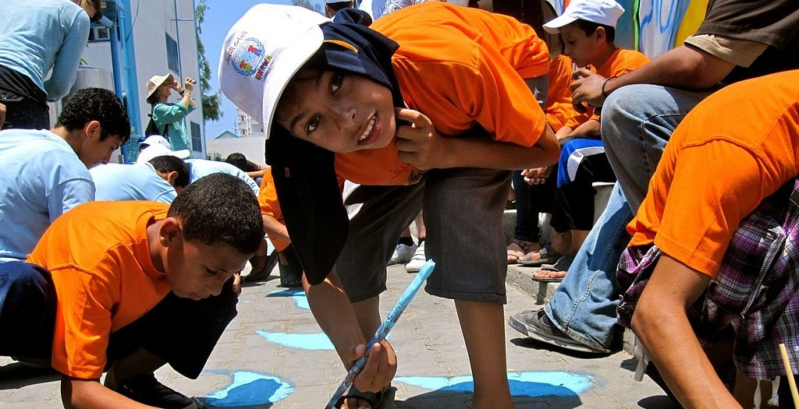

**[BTS/MAP](http://breakthesilencearts.org/)& Estria Foundation present**

**EMERGENCY RESPONSE FOR GAZA  
for the** [**Middle East Children’s Alliance**](http://www.mecaforpeace.org/) **to bring medical supplies**

**and support for psychological services directly to Gaza**

**Sunday, December 9th @ 4pm**

**Eric Quezada Center**

**518 Valencia St. @ 16th in SF**

**A SILENT ART+ AUCTION**

**SF Art Drop Off**:   
1:30-3:30PM Sun. Dec. 9th, 518 Valencia St.

**East Bay Art Drop Off**:

Please contact  
[**www.nancypili@estria.org**](http://www.nancypili@estria.org)**;** (510) 698-6640

**Alternate Art Drop Off**:Please call 415-271-0576 or email: [susangreene@  
mindspring.com](mailto:susangreene@mindspring.com)

**Speakers and Performers Include**

***Ayman Nijim***, mental health worker visiting from Gaza

***Genny Lim,***poet, will perform with ***Dr. Hafez Modirsadeh on sax***

***Julie Thi Underhill****,* activist-poet, UC Berkeley

***Dr. Susan Greene*,** BTSMAP director

***Wenceslao Quiroz,*** *muralist painting in Palestine*

***Vyal One,*** *2-time Graffiti Battle Kings, In Gaza with #WaterWrites Project.*

***Excentrik:*** *Oud and Hip Hop*

**Contributing Artists Include**

Nidal El Khairy, Juana Alicia, Jos Sances, Eric Drooker, Vyal One, Josue Rojas, Mike Bam, Drama, Favianna Rodriguez, Bounce, Doug Minkler, Miranda Bergman, Marlene Tobias, MAIA Mural Brigade and MORE!

**… AND surprise guests TBA**

FOR MORE INFORMATION <http://www.facebook.com/btsmap?ref=hl>

**SAVE THE DATE – PLEASE FORWARD WIDELY**