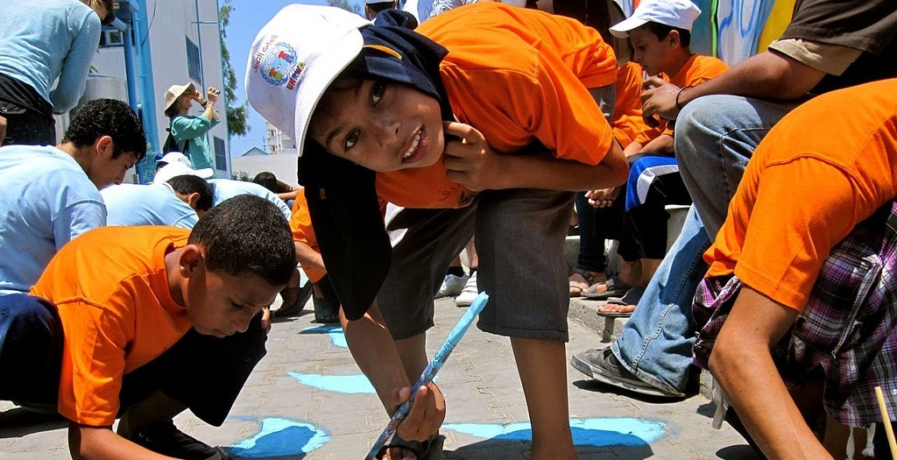
BTS/MAP& Estria Foundation present
EMERGENCY RESPONSE FOR GAZA
Help Middle East Children’s Alliance bring medical supplies
and support for psychological services directly to Gaza

ON-LINE AUCTION IS BEING SET UP
PLEASE EMAIL INFO@HANDALA.ORG and we will alert you when the bidding starts.
Contributing Artists Include
Nidal El Khairy, Juana Alicia, Jos Sances, Vyal One, Josue Rojas, Mike Bam, Drama, Favianna Rodriguez, Bounce, Doug Minkler, Miranda Bergman, Marlene Tobias, Fred Alvarado, Shadi Alqarra, Wenz, Maggie Yee, Eman Mohummad, Amaryllis DeJesus Molesk, Susan Almazol, Paulette Norberg, Francisco Letelier, Nancypili and more!

CHECK OUT THE EXHIBIT AT CHARLIE’S CAFÉ
3202 Folsom St, SF CA, (415) 641-5051

